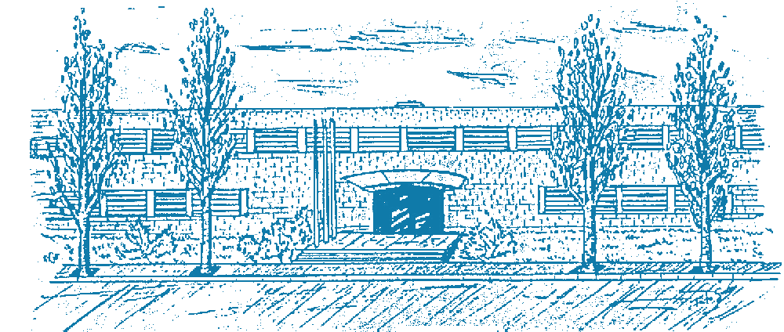



Title: The Regularity Lemma for Stable Graphs and its applications in Property Testing

Author: Severino Da Dalt

Advisor: Lluís Vena Cros

Department: Department of Mathematics

Academic year: 2024/2025
Master of Science in
Advanced Mathematics and Mathematical Engineering

